The Drovers Rest

(Restaurant & Accommodation) Peter R. James MBE.
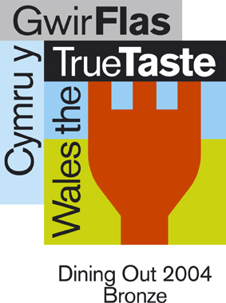

Dol-y-coed Road
Llanwrtyd Wells
Powys
LD5 4RA
Tel: 01591 610264
Or 01591 610563


E-mail: foodfoodfood@lycos.com
Web site: www.food-food-food.co.uk

SAMPLE FRESH MENU DAILY

Starters

Chef's Home-made Soup of the Day
finished with croutons
served with roll and butter

Duo of Cheeses Pasta Bake
Cheddar and Parmigiano
on a bed of pasta with a spicy Salsa sauce

Local Bacon & Spicy Meat Balls Salad
Slices of crispy bacon with a garlic and chilli sauce

Mains

Pork Normandy
served with a mushroom, garlic & Cognac cream sauce
finished with parsnip crisps

Pan Fried Chicken Breast
served with an leek sauce

Sea Bass Fillet
Fillet of fresh sea bass served a fresh herb & cream sauce
on a bed of spinach

Cheese & Cranberry Tart
on a bed of rocket salad
served with a red onion sauce

All above served with a selection of fresh vegetables

A Selection of 3 home-made desserts

ANY SPECIAL DIETERY REQUIREMENTS PLEASE NOTIFY US

